**<Demo mode爱车探索 - 需求文档>**

MRD/PRD文档

版本 <V1.0>

|  |  |  |  |  |  |  |
| --- | --- | --- | --- | --- | --- | --- |
| Screen Sizes available in: | | |  |  |  |  |
|  | **12"L** | **12.8" P** | **12.8"L** | **13.2"L** | **27"L** | **15.5"P** |
| Ford |  |  |  | * | * |  |
| Lincoln |  |  |  |  |  |  |
| Theme |  |  |  |  | Phase 4 |  |

**修订历史 Change log**

|  |  |  |  |
| --- | --- | --- | --- |
| **版本号** | **修订日期** | **修订者** | **修订内容** |
| <V1.0> | <2021/1/16> | Xiao Yun (yxiao21) | 初稿 – 基于phase4 27’屏的IVI项目，搭建Demo mode 功能框架，满足亮点功能介绍的基础需求。 |

目录 Content

**1.** **需求介绍 Requirement intro** 3

1.1 需求背景 Background 3

1.2 需求时间 Timing 3

**2.** **需求内容 Request contents** 3

2.1 Feature break done 功能点 3

2.2 功能入口 - Access 3

2.2.1 Demo mode入口 – Full Screen mode 3

2.3 功能详情 Feature details 3

2.3.1 Demo videos 3

**2.3.2** **Content texts** 5

2.3.3 Unwatched video reminders 5

2.3.4 Link to other apps 5

2.3.5 Special cases/error cases 6

2.3.6 Variants for configuration 6

2.3.7 Video storoge 6

2.3.8 Access to demo mode 6

2.3.9 Interactive user guide 7

2.3.10 Motivation design to customer 7

1. **需求介绍 Requirement intro**
   1. 需求背景 Background

Demo mode(Chinese name for Ford - 爱车探索, Lincoln TBD) is a feature in IVI to provide customer an access to know the highlights of the vehicle in dealership before purchase, as well as an acess to know what’s new in the car after purchase along with over the air updates.

The intent is to interest customer prior to purchase and excite them after purchase, which is one of the key to differentiate from competitors.

* 1. 需求时间 Timing

发布时间：Sync+的Phase 4阶段

1. **需求内容 Request contents**
   1. Feature break done 功能点

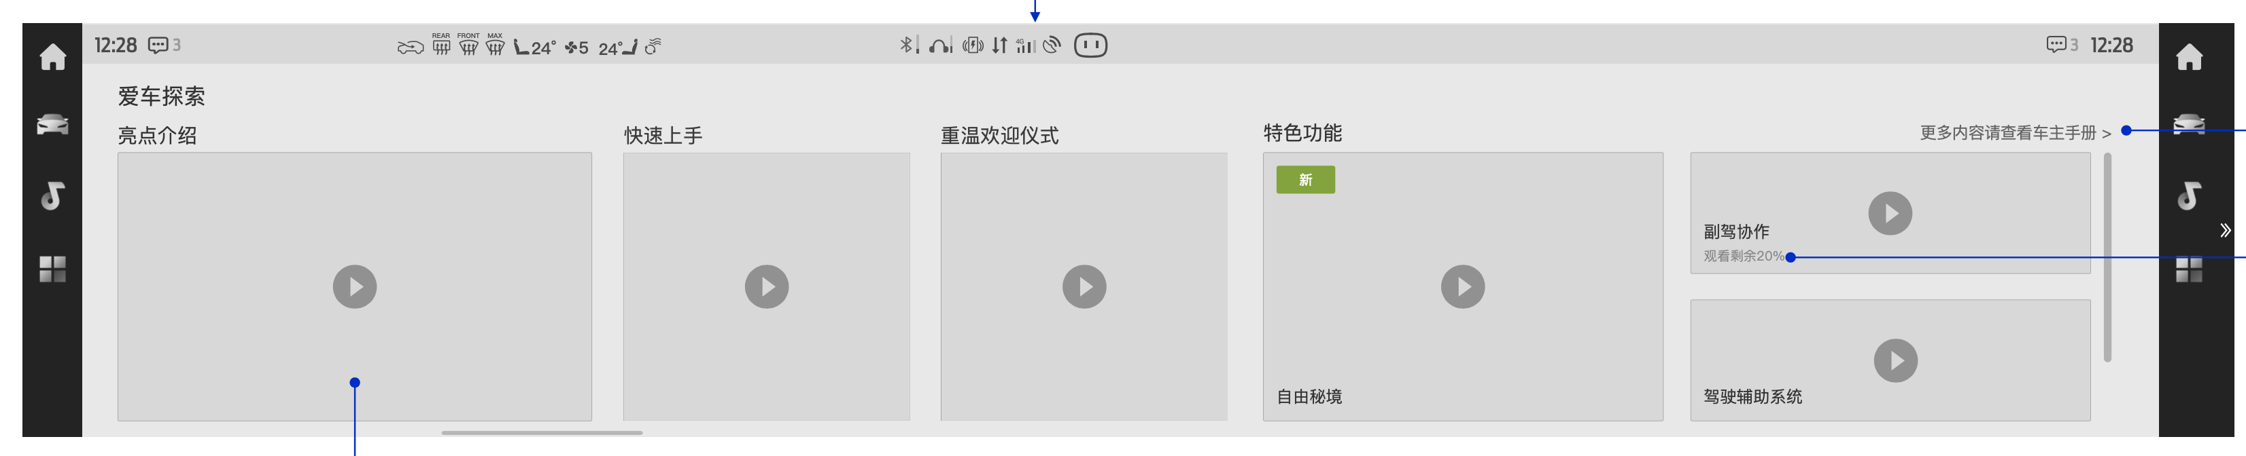

1. Demo videos
2. Content texts
3. Unwatched video reminders
4. Link to other applications
   1. 功能入口 - Access
      1. Demo mode入口 – Full Screen mode

入口位于：车机进入‘更多服务’，点击【爱车探索】卡片进入APP

* 1. 功能详情 Feature details
     1. Demo videos

Video contents

1. Pre- purchase video

Based on Marketing & Branding input, to show the highlights of vehicle, including vehicle appearance, service & features.

1. Rocket set up & Tips video

The video shall be able to help customer understand how to operate the system (Tips of the the system level interactions, gesture controls), and how to set up to use the system after perchuse (CD 542 - account settings, face ID).

The rocket set up video storyboard shall be consistent across carlines for the programs sharing same data & account strategy.

Currently most connectivity features are not available if customer haven’t log in with valid real name registration due to data strategy. So this video shall be stored locally in the system to enable customer find out what to do at the beginning.

1. Welcome approach/ Lincoln Embrace video

To demonstrate the holistic welcome strategy of the vehicle, including vehicle unlock, door open & IVI boot up stage and the exterior/ambient lighting behaviors.

Vehicle exterior & interior will be shown in this video.

1. Feature walkthrough

Based on program content, highlight features’ demo video will be integrated in this part.

CD542 – Relas/At ease, DAT functions, Surprise message, Co-pilot & Co-driver.

CD764 –

1. DAT2.0 / V2I / TFT HUD
2. 27 inch screen
3. Wow seat
4. Relax Mode / Digital scent
5. Premium Audio
6. LW remote control and PAAK
7. Enhance Memory
8. X128 ambient lighting (music sync)
9. Smart Scene

Demo mode video player rules

All the videos are leveraging system level media player capability, including play, pause, volume & brightness adjustment, fast forward & fast reverse.

Directly locate to specific chapter of video is supported. Customer can review the chapters listed & the chapters are marked in the video player bar.

The sytem shall remember if the video has been watched by the logged-in account.

* + 1. Content texts

Contents texts are provided to briefly explain the video content.

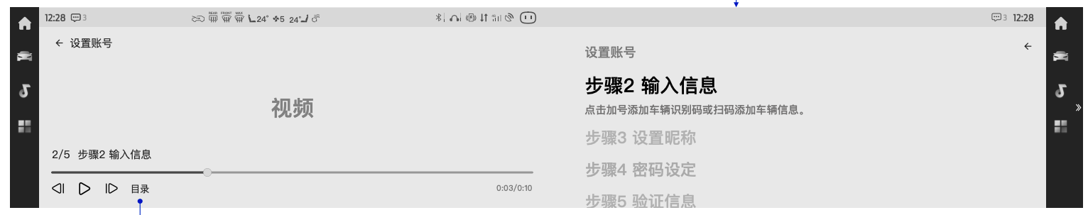

* + 1. Unwatched video reminders

A tag to indicate new videos should be added in the video card to interest customer.

The rocket set up & tips video shall be prioritized to new customer, to help customer know the system better.

The unwatched videos shall be prioritized in the video playlist.

There shall be ‘x% to end’in the video card to enable customer quick start from last watched video, in consistent design & logic with online video APP in the system.

* + 1. Link to other apps

There should be access to E-Manual in the home page of demo mode feature for customer to refer detailed function instructions.

There should be access to according feature at the end of each feature walkthrough video.

QR code access shall be provided after each video is watched, to enable customer to watch it in phone & share in social media. *(CD542 can be an exception)

* + 1. Special cases/error cases

The feature design shall be compliance with non-driving-distraction rules.

CD764/CD542 – based on system level rules, video player shall be terminated while vehicle speed is > 5km/h, as well as notifying customer ‘don’t get distracted while driving’.

The feature is in a low system priority, which can be interrupted by driving related features like parking aid, rear camer views, hard button interactions, etc.

10 sec timer is provided if there’s a system failure happen when customer operated.

Re-try access shall be provided when the system is failed to read the stored videos or execute actions customer is intent to do.

* + 1. Variants for configuration

Detailed config to be defined in late stage along with holistic system configure bite development.

CD542 – 5dr & 4dr vehicle render to be configured

CD764 – 103A lux & sport vehicle render to be configured; feature walkthrough to be configured based on vehicle contents.

* + 1. Video storage

The video shall be pre-stored in local.

Capability to be considered to load streaming videos.

* + 1. Access to demo mode

1. More services

Persistently, there shall be a demo mode entry in ‘More services’.

There shall be a demo mode dash card defaultly in launcher & enable customer to continue watching last unwatched video.

1. Home screen

For the accounts first logs into the system, the demo mode dash card shall be shown in launcher & highlighted, to indicate customer to watch the videos.

1. Account login page

When there’s no account logged into the system, there shall be a link to ‘rocket set up & tips’video link in the page, to enable customer can explore what the system can do after log in. – to be aligned

There shall be a link to ‘rocket set up & tips’video in account login page. – aligned with account feature owner.

* + 1. Interactive user guide

– TBD （post CD764 PEC）

* + 1. Motivation design to customer (激励计划)

– TBD （post CD764 PEC）

* Considered content : medals to customer in account system; motivated peoms in the page to be shown dynamically.